**Chapter 6**

**Applications of Integration**

**6.2 Determining Volumes by Slicing**

**Section Exercises**

59. Use the slicing method to derive the formula for the volume of a cone.

Answer: This is a proof; therefore, no answer is provided.

61. Use the disk method to derive the formula for the volume of a trapezoidal cylinder.

Answer: This is a proof; therefore, no answer is provided.

**For the following exercises, draw a typical slice and find the volume using the slicing method for the given volume.**

63. A pyramid with height 6 units and square base of side 2 units, as pictured here.

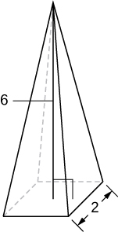

Answer: 8 units3

65. A tetrahedron with a base side of 4 units, as seen here.

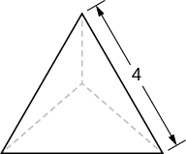

Answer: units3

67. A cone of radius  and height  has a smaller cone of radius  and height 

removed from the top, as seen here. The resulting solid is called a *frustum*.

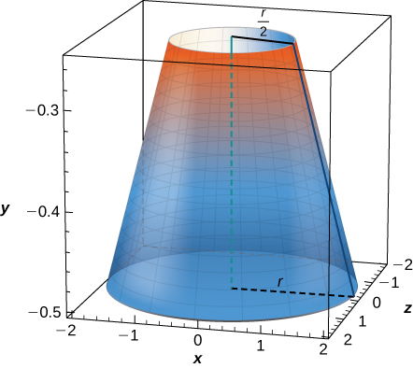

Answer: units3

**For the following exercises, draw an outline of the solid and find the volume using the slicing method.**

69. The base is a triangle with vertices  and  Slices perpendicular to the *xy*-plane are semicircles.

Answer:

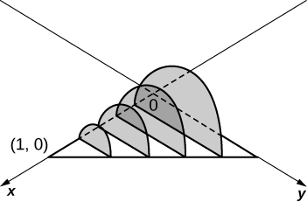

 units3

71. The base is the region under the parabola and above the  Slices perpendicular to the are squares.

Answer:

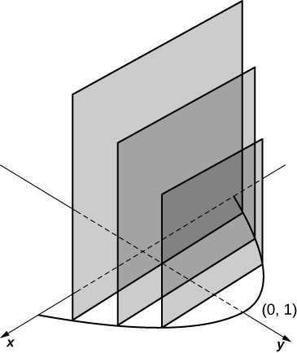

 units3

73. The base is the area betweenand Slices perpendicular to the *x*-axis are semicircles.

Answer:

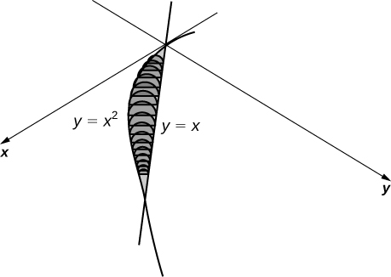

 units3

**For the following exercises, draw the region bounded by the curves. Then, use the disk method to find the volume when the region is rotated around the *x*-axis.**

75. 

Answer:

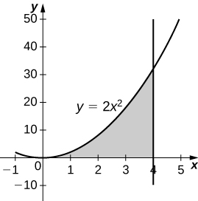

 units3

77. 

Answer:

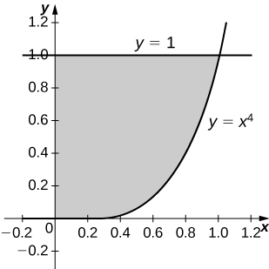

 units3

79. 

Answer:

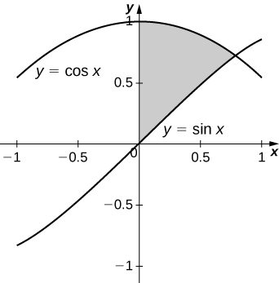

 units3

81. 

Answer:

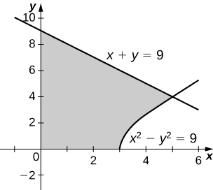

 units3

**For the following exercises, draw the region bounded by the curves. Then, find the volume when the region is rotated around the *y*-axis.**

83. 

Answer:

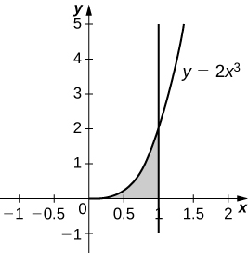

 units3

85. 

Answer:

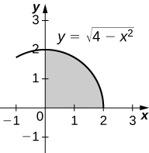

 units3

87. 

Answer:

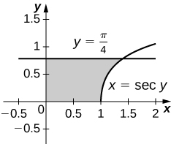

 units3

89. 

Answer:

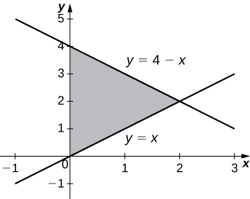

 units3

**For the following exercises, draw the region bounded by the curves. Then, find the volume when the region is rotated around the *x*-axis.**

91. 

Answer:

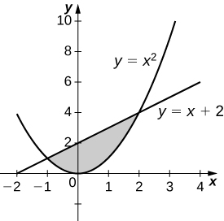

 units3

93. 

Answer:

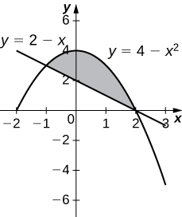

 units3

95. 

Answer:

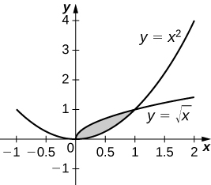

 units3

97. 

Answer:

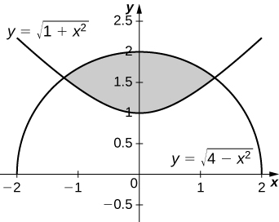

 units3

**For the following exercises, draw the region bounded by the curves. Then, use the washer method to find the volume when the region is revolved around the *y*-axis.**

99. 

Answer:

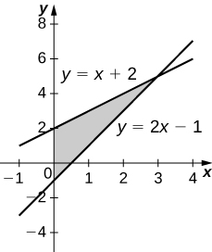

 units3

101. 

Answer:

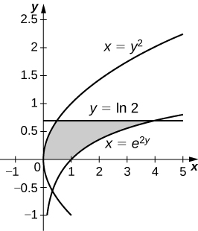

 units3

103. Yogurt containers can be shaped like frustums. Rotate the line around the *y*-axis to find the volume between .

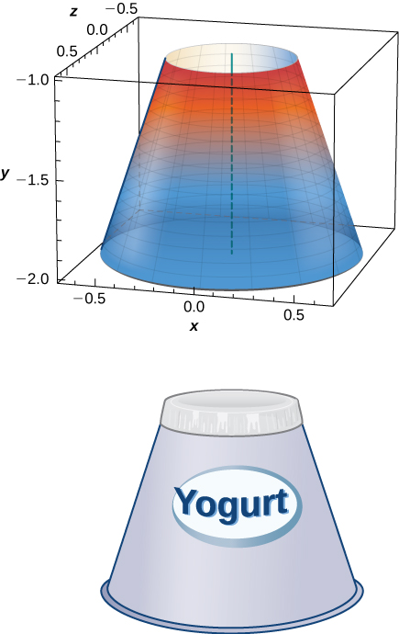

Answer: units3

105. Rotate the ellipse around the *y*-axis to approximate the volume of a football.

Answer:  units3

107. What is the volume of the Bundt cake that comes from rotating  around the *y*-axis from  to ?

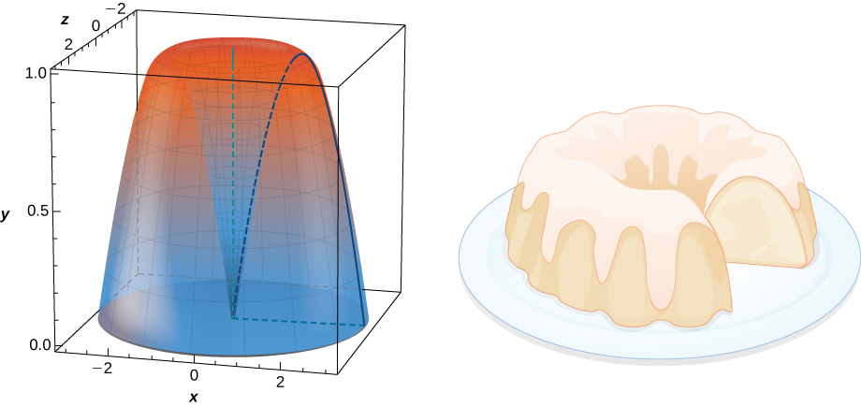

Answer:  units3

**For the following exercises, find the volume of the solid described.**

109. The base is the region enclosed by the generic ellipse. Slices perpendicular to the *x*-axis are semicircles.

Answer:  units3

111. Find the volume common to two spheres of radius  with centers that are apart, as shown here.

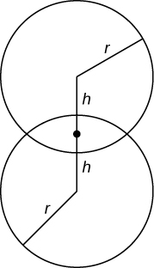

Answer: units3

113. Find the volume of a sphere of radius with a cap of height removed from the top, as seen here.

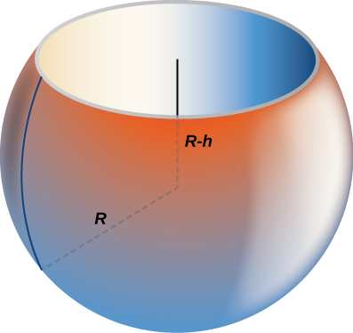

Answer: units3

This file is copyright 2016, Rice University. All Rights Reserved.